Key System Components
The system relies on three fundamental components, each structured using standard Python data types for efficient data handling:
- Books: Managed through a dictionary where the ISBN (International Standard Book Number) serves as the unique identifier (key), linking to a record of details like title, author, genre, and the crucial total_copies count.
- Members: Managed as a list of dictionaries, each containing unique details such as member_id, name, and email, alongside a dynamic list called borrowed_books to track current loans.
- Genres: Defined by a tuple of valid genre strings (e.g., 'Fiction', 'Non-Fiction', 'Sci-Fi') to ensure data integrity during book creation and updates.

Core Functionality
The system implements a comprehensive set of functions to control data integrity and manage library transactions:
- CRUD Operations: Functions for Creating (add_book, add_member), Reading (search_books), Updating (update_book, update_member), and Deleting (delete_book, delete_member) records. Crucially, deletion is restricted if a book is currently borrowed or a member has outstanding loans.
- Transaction Logic: Dedicated functions (borrow_book, return_book) ensure transactional accuracy. The borrow_book function enforces a strict limit of 3 books per member and checks for book availability before processing the loan, while return_book verifies the transaction and updates the book's copy count.
This design provides a clear, testable, and functional framework for managing a small-scale library inventory and its patrons.

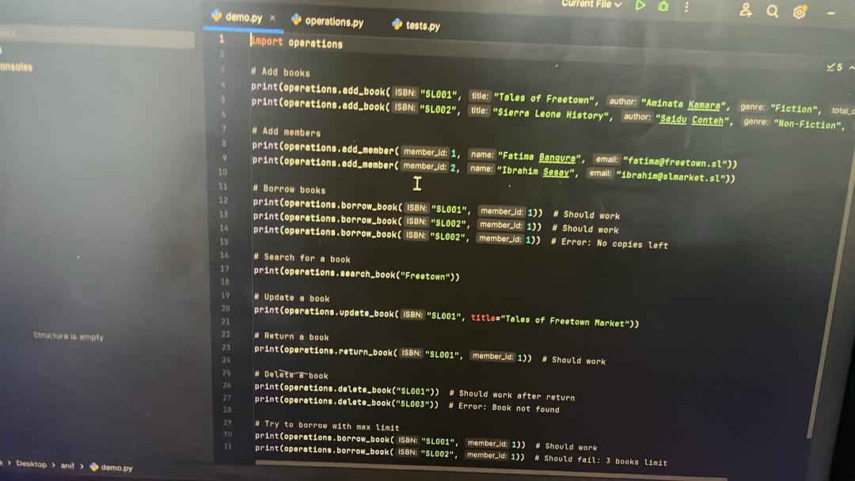

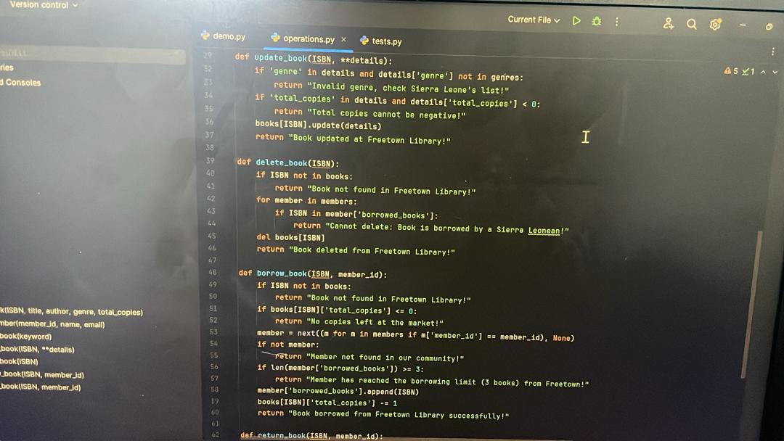

Test Script (tests.py)
This diagram shows a test script written to verify that the functions in the separate operations module work correctly.
- Purpose: It acts as a checklist, calling every core library function (add_book, borrow_book, update_book, delete_book, etc.) with specific data.
- Key Actions:
  - Setup: Adds two books (SL001, SL002) and two members (1, 2).
  - Borrowing: Tests successful borrows, failure due to no copies left, and failure due to the 3 books per member limit.
  - Updates & Returns: Tests modifying a book's title and returning a borrowed book.
  - Deletion: Tests deleting a book only after it has been returned.
- Goal: To print the result of each action to ensure the operations.py module is functioning as intended.

2. Operations Module (operations.py) - Functions
These diagrams show the actual logic and rules for the Library Management System, defining how data is manipulated.

A. update_book and delete_book
- update_book(): Allows changes to book details (like title or copies). It includes guard checks to prevent setting negative copies or using an invalid genre.
- delete_book(): Removes a book from the system. It has a crucial rule: the book cannot be deleted if any member currently has it marked in their 'borrowed_books' list.

B. borrow_book and return_book
- borrow_book(): The loan process. It performs four checks before allowing a borrow:
  - Book must exist.
  - Copies must be available.
  - Member must exist.
  - Member must not have reached the 3 books borrowing limit.
  - If successful: It removes 1 from the book's total copies and adds the ISBN to the member's borrowed list.
- return_book(): The return process. It checks that the member actually borrowed that specific book before proceeding.
  - If successful: It adds 1 back to the book's total copies and removes the ISBN from the member's borrowed list.

The Test Script (tests.py)
This file is designed to validate the functionality of the operations module. It systematically runs through every possible scenario, including successful actions and expected failures.
Test Section | Purpose | Key Checks
Setup | Initializes the library with basic data. | Adds two books (SL001, SL002) and two members (1, 2).
Borrowing | Tests the basic lending mechanism and copy counts. | Confirms a book can be borrowed successfully, then verifies that borrowing a book with no copies left returns an error.
Search & Update | Tests retrieval and modification of data. | Checks if a book can be found by a keyword (e.g., "Freetown"). Updates the title of book SL001.
Return & Delete | Tests removal and availability. | Confirms a book can be successfully returned, increasing the available copies. Checks that a book can only be deleted after it has been returned.
Limit Test | Ensures rules are enforced. | Confirms that a member who has reached the limit of 3 borrowed books is correctly prevented from taking out another.

The Operations Module (operations.py)
This file contains the business logic for the library. It uses dictionaries (books) and lists of dictionaries (members) to store data and defines functions to manage that data.

1. Data Management Functions (CRUD)
Function | Logic Summary | Key Rule Enforcement
add_book() / add_member() | Creates new records. | Checks for unique ISBN and unique member ID to prevent duplication.
update_book() | Modifies a book's details. | Prevents setting copies to a negative value and ensures any updated genre is valid.
delete_book() | Removes a book record. | The most critical check: deletion is forbidden if the book's ISBN is found in any member's list of borrowed books.
search_book() | Retrieves records. | Finds and returns books where the search keyword matches the title or author.

2. Transaction Functions (Borrow/Return)
Function | Detailed Logic | Transactional Impact
borrow_book() | Loan Process. It must pass four main checks: Book exists, copies available, member exists, and member has not hit the 3-book limit. | Decrements the book's total_copies by 1. Appends the ISBN to the member's borrowed_books list.
return_book() | Return Process. It must confirm the member actually has the book marked as borrowed before proceeding. | Increments the book's total_copies by 1. Removes the ISBN from the member's borrowed_books list.

UML DIAGRAM (HAND DRAWN)

Library Management System Design
1. Data Structures (The Nouns)
The system uses two primary data containers, which would likely be implemented as dictionaries or lists of dictionaries in Python.
Diagram Box | Name (Concept) | Key Attributes (Details Stored)
Book | Individual book record. | title
 |  | author
 |  | genre
Member | Individual library patron record. | name
 |  | email
 |  | borrowed_book (A list or set of ISBNs for currently borrowed books)
Library | The central container/module. | books_dict (A dictionary holding all Book records, usually keyed by ISBN)
 |  | members_dict (A list or dictionary holding all Member records, usually keyed by Member ID)
Export to Sheets

2. Functions (The Verbs)
These functions represent the actions or operations that the library module can perform to interact with the Book and Member data structures.
Function Group | Functions Listed | Purpose
Core (CRUD) | add-book | Adds a new book to the books_dict.
 | add-member | Adds a new member to the members_dict.
 | Search-books | Retrieves book information based on criteria (e.g., title, author).
 | Update-book | Modifies details of an existing book.
 | Update-member | Modifies details of an existing member.
 | delete-book | Removes a book from the system.
 | delete-member | Removes a member from the system.
Transactions | borrow-book | Processes a book loan to a member.
 | return-book | Processes a book return from a member.
Export to Sheets
Conclusion: Freetown Library Management System
This project successfully established a functional and conceptually sound framework for a Library Management System, demonstrated through Python code and a clear structural diagram.

Key System Strengths
- Modular Design: The system is cleanly separated into core Data Structures (Book and Member records) and Core Functions (the operations performed on that data).
- Data Integrity: The use of distinct dictionaries/lists for books and members ensures that records are organized, and transactions consistently update both the book inventory (total_copies) and the member's borrowing history (borrowed_books).
- Enforced Rules: The system implements critical business logic, specifically:
  - Borrowing Limit: Members are restricted to a maximum of 3 borrowed books.
  - Safe Deletion: Books cannot be deleted from the catalog if they are currently on loan to any member.
In essence, the system provides a robust and reliable foundation for managing day-to-day library operations, validating user input, and enforcing library policies.

